Archaeological excavations at Silloans, Otterburn, Northumberland

No Man’s Land were asked by Defence Estates to assist in the excavation and interpretation of a set of Great War-style practice trenches on Defence Training Estate Otterburn. Although surviving well and of interest to tourists and military historians the trenches are in the Range Danger Area and are normally not available to visit. One of the purposes of the exercise was to gather material that could be used to present the trenches to the public.

The trenches at Silloans are a Scheduled Ancient Monument. Consents for the work were obtained by the Defence Estates Historic Environment Team and one of their number acted as project leader.

The purpose of the work was primarily to confirm the purpose and date of the site. Trenches such as this example were created for a variety of training needs over about 25 years between 1914 and 1940, when the German Blitzkrieg proved them to be redundant. We hoped archaeological evidence would provide more information about this well-preserved example. Remnants of parts of a trench mortar bomb and fuze caps from a number of shells demonstrated that combat training had taken place here, while the lack of rusty tins suggested that trench life had possibly not been practised, due to the lack of food remains. A lack of fired cartridges meant that the soldiers had not been practising infantry combat. The mortar remains also gave a secure Great War date, as did some of the construction methods.

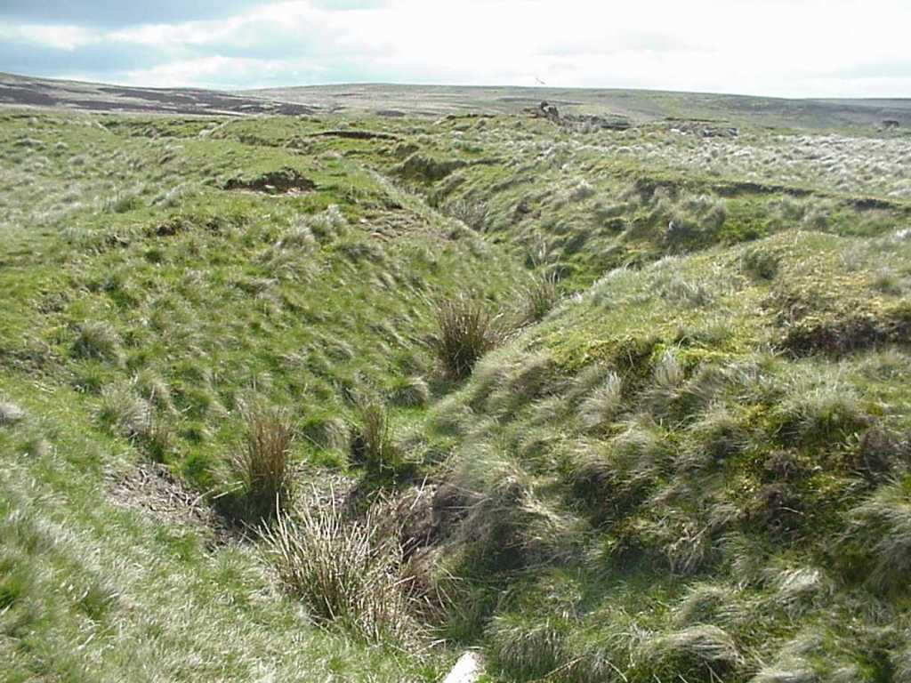
A general view across the Silloans trenches prior to investigation.

The Excavation
Excavation revealed interesting details of trench construction, including methods of revetting the trench. A variety of construction styles had been employed, each one reflecting the different soil types across the site and possible phases of construction. Several trenches were dug across the military earthworks to see how they had been constructed. Each trench was placed to look at a different part of the system: Trench One was on the Front Line; Trench Two was in one of the communication trenches; Trench Three was intended to explore the possible collapsed dugout and Trench Four was to investigate a hollow in the wall of one of the communication trenches that could have been another dugout. Later on Trench Five was dug to look at the second line or Support Trench.

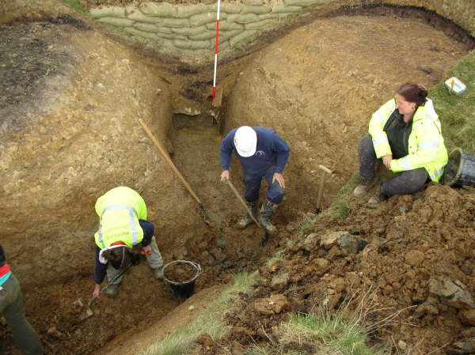
Excavation in progress in Area 1

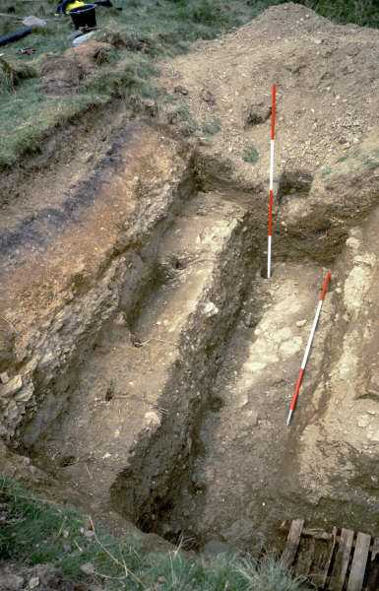
Trench One revealed a wide, deep trench with no obvious revetment to hold the sides in place. This trench was wide and easy to work in but it produced no significant finds to say anything about its usage.

Trench Two showed a very complete piece of trench with revetment, trench boards on the floor and a fire step on which men could stand to shoot at the enemy. When not in action the fire step was also the place where men could sit, sleep and cook. The wooden trench boards on the bottom of the trench helped the soldiers walk on a relatively secure and dry surface.

Area 2 after excavation. The classic trench form exhibited includes a
firestep, trench boards and sharply angled traverses.

Trenches Three, Four and Five showed no obvious construction features so were probably similar in appearance to Trench One, though not so wide. However Trench Five did have the remains of a shallow and badly degraded Fire Step.

Interestingly one feature excavated in trench three turned out to be a 1980s forward observation post (with dates provided by SA80 cartridge cases and ration wrappers).

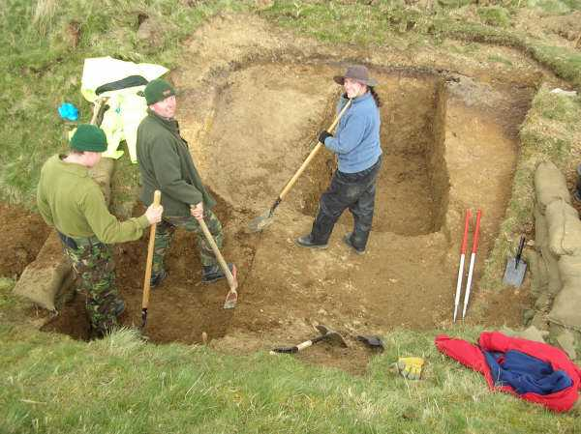
A mixed civilian and military team at work on what turned out to be the
1980's training feature!

Interpretation
It is possible that there was no single plan for this trench system. It may be that it just developed as soldiers arrived at Silloans to train for war. Trench 5 looks like a classic early war Fire Trench but Trench 1 looks like a much later defence, possibly copying German positions in particularly strong positions like the Hindenburg Line. Maybe an earlier Front Line trench was destroyed when it was dug. However this must remain supposition as nothing was found to substantiate this theory.

Was the lack of food tins and other domestic rubbish the result of a good clean-up job or because soldiers didn’t live in these trenches? Does the lack of rifle ammunition mean they never practised trench warfare here? Most importantly does the large amount of artillery ammunition show that these trenches were used as a target feature, helping trainee Gunners learn their craft?

Evidence of infantry combat training can include fragments of hand grenades found in them or the fired cartridges from rifles and machine guns. Nothing like this was found at Silloans but there were parts of shells and the firing mechanism for a Stokes Mortar bomb, all of which suggest that the trenches were used for training in digging and then as an artillery target. This interpretation would certainly fit with historical data that suggests that this area was used primarily for artillery training.

The lack of both food remains and bombs and bullets suggests that the trenches were initially used for practice in digging and construction but that they were then used as an artillery target. This fits with historical researches undertaken in support of the project. Initially the Northumberland Fusiliers were thought to be the most likely candidates for the builders of these trenches but they appear not to have trained at Otterburn. However the nearby Redesdale Camp was heavily used by the Royal Artillery during and after the Great War so it seems most likely that they were responsible for the construction and shelling of the trenches. Alarmingly, and perhaps tellingly, the area around the trenches exhibits plenty of shell damage when viewed on aerial photographs but the trenches themselves are relatively undamaged!

The use of the trenches for artillery training does raise another suggestion about the different styles of construction visible in different areas of the monument. It may be that the artillery were assessing different styles of trench for head cover and/or practicing skills for shelling them.

One thing is certain; although these trenches have many features of the trenches in France there is nothing that looks like a Trench Latrine. Maybe that is the biggest clue that the soldiers didn’t spend days and nights out in the trenches.

Discussion
Whatever these trenches tell us they do show how soldiers trained for the Great War. They didn’t go to France never having seen trenches and without proper training. They were skilled at the essential tasks of digging, revetting and making safe. Being in trenches was relatively safe, and gave protection from bombs and bullets. What they learned here helped save lives.

Across Europe there are many memorials to the soldiers of the Great War. Many are very fine things of marble but in its own quiet way Silloans is as much a memorial to the men of 1914-1918. The men who dug these trenches were ordinary blokes who did something remarkable.

Acknowledgements
EOD support came from XI Regiment EOD, part of the Royal Logistics Corps. When not making safe explosives all four members of the EOD team contributed to the excavation, including digging and surveying.

The whole team is also grateful to Duncan Glen of DE at Otterburn for his assistance and to Landmarc for providing accommodation in a troop shelter, which was much nicer than it sounded!

NML would like to thanks Defence Estates for the opportunity to contribute to this project.
English Heritage and the Northumberland National Park both retained oversight of the project and their support is gratefully acknowledged.

